**COPYRIGHT**

The author has agreed that the library, Department of Civil Engineering Thapathali Campus, Institute of Engineering may make this report freely available for inspection. Moreover, the author has agreed that permission for extensive copying of this report for scholarly purpose may be granted by the professor(s) who supervised the work recorded herein or, in their absence, by the Head of the Department wherein the report was done. It is understood that the recognition will be given to the author of this report and to the Department of Civil Engineering, Thapathali Campus, Institute of Engineering in any use of the material of this report. Copying or publication or the other use of this report for financial gain without approval of the Department of Civil Engineering, Thapathali Campus, Institute of Engineering and author’s written permission is prohibited.

Request for permission to copy or to make any other use of the material in this report in whole or in part should be addressed to:

----------------------------------------------

Head

Department of Civil Engineering

Thapathali Campus, Institute of Engineering

Kathmandu, Nepal



# Cover Page

TRIBHUVAN UNIVERSITY

INSTITUTE OF ENGINEERING

THAPATHALI CAMPUS

DEPARTMENT OF CIVIL ENGINEERING

**FORMULATION OF COMPUTER APPLICATION FOR DESIGN OF PRESTRESSED BOX GIRDER BRIDGE**

BY

AASHISH GHIMIRE(THA074BCE002)

BISHAL SHAKYA(THA074BCE026)

EMADUDDIN AHMAD(THA074BCE032)

KUSHAL ACHARYATHA074BCE045)

MILAN JOSHI(THA074BCE046)

NIKESH DAWADI(THA074BCE048)

IN PARTIAL FULFILMENT OF THE REQUIREMENT FOR THE

BACHELOR'S DEGREE IN CIVILENGINEERING

January, 2022

Kathmandu, Nepal

# Title Page



TRIBHUVAN UNIVERSITY

INSTITUTE OF ENGINEERING

THAPATHALI CAMPUS

DEPARTMENT OF CIVIL ENGINEERING

**DESIGN OF PRESTRESSED BOX GIRDER BRIDGE**

BY

AASHISH GHIMIRE(THA074BCE002)

BISHAL SHAKYA(THA074BCE026)

EMADUDDIN AHMAD(THA074BCE032)

KUSHAL ACHARYATHA074BCE045)

MILAN JOSHI(THA074BCE046)

NIKESH DAWADI(THA074BCE048)

IN PARTIAL FULFILMENT OF THE REQUIREMENT FOR THE

BACHELOR'S DEGREE IN CIVILENGINEERING

January, 2022

Kathmandu, Nepal

# Certificate

TRIBHUVAN UNIVERSITY

INSTITUTE OF ENGINEERING

THAPATHALI CAMPUS

DEPARTMENT OF CIVIL ENGINEERING

**CERTIFICATE**

This is to certify that the work contained in this report entitled **"** **Design of prestressed box girder bridge"** in partial fulfillment of the requirement for the Bachelor's degree in Civil Engineering, as a record of research work, has been carried out by **“Aashish Ghimire(THA074BCE002)”** under my supervision and guidance in the Institute ofEngineering, Thapathali Campus, Kathmandu, Nepal. The work embodied in this report has been submitted elsewhere for degree.

_____________________________________________

Supervisor, name of Supervisor

Title

Name of the Department

_____________________________________________

Co- Supervisor, name of Co-Supervisor,

Title

Name of the Organization,

Date

TRIBHUVAN UNIVERSITY

INSTITUTE OF ENGINEERING

THAPATHALI CAMPUS

DEPARTMENT OF CIVIL ENGINEERING

**DESIGN OF PRESTRESSED BOX GIRDER BRIDGE**

By

AASHISH GHIMIRE(THA074BCE002)

A project report submitted in partial fulfillment of the requirements of the Bachelor's Degree in Civil Engineering

|  |  |  |
| --- | --- | --- |
| …………………………… | …………………………… |  |
| Name | Name |  |
| Supervisor | Internal Examiner |  |
|  |  |

|  |  |  |
| --- | --- | --- |
| …………………………… | …………………………… |  |
| Name |  |  |
| External Examiner | Head of Department, Civil |  |
| IOE, Thapathali Campus |  |
|  |  |

July, 2020

Kathmandu, Nepal

# Acknowledgements

**ACKNOWLEDGEMENTS**

I am greatly indebted to my project supervisor Professor Sakhil Manandhar for providing me with definite direction, professional guidance, and constant encouragement from the beginning of the work and moral support in many ways during study period.

I am also greatly indebted to Er. Biswa K. Balla of Institute of Engineering, for his valuable suggestion and direction to accomplish the study.

I would like to express my sincere thanks to Name, Name and Name, of Organization, for their outstanding suggestions and cooperation received during the study period.

I acknowledge the help, advice and guidance rendered by Head of the Civil Engineering Department, Ram Pd. Neupane. The support provided by Administrative staffs, Name is unforgettable.

I am also grateful to all the colleagues …………………………………………. .

**ABSTRACT**

# **CHAPTER I**

## **INTRODUCTION**

## **1.0.1General Background**

Design of structures involves the designing of various types of structures such as residential buildings, bridges, multi-storied frame structures, steel towers etc. These structures are subjected to various loads such as uniformly distributed loads, uniformly varying loads, point loads, internal loads etc. which may subject the structure to shear force, axial force, bending and torsional moments. These structures serve to transfer the load to the soil on which their foundations lie, such that the structure is able to serve its purpose without risk of failure in any form.

The designing of bridges requires analysis of internal forces in the members of the structure. The designing of bridges requires sizing of members to resist the internal forces that occur in the members so as to allow the structure to appropriately serve its purpose for its intended useful life. Without proper analysis and designing of bridge according to the provided guidelines via the specified standard code (Nepal Bridge Standards-2067), the structure will not be able to serve its intended purpose and may result in failure and loss of both finances and civilian lives.

This project undertakes the task of automation of design of prestressed box girder bridge using python programming language. With a program designed specifically for the purpose of design of prestressed box girder bridges, the process can be made easy, fast and reliable for similar projects.

Python is a widely used general-purpose, high level programming language. It was created by Guido van Rossum in 1991 and further developed by the Python Software Foundation. It was designed with an emphasis on code readability, and its syntax allows programmers to express their concepts in fewer lines of code.

This project has been undertaken as an essential requirement for bachelor’s degree in civil engineering as specified under the course content provided by Institute of Engineering, Tribhuvan University. The project aims to analyze the proposed bridge structure, provide design and detailing as well as provide an appropriate estimate of its durability (safety) and cost of construction. All the theoretical knowledge acquired have been accordingly utilized for practical application for the analysis, design and detailing of the proposed bridge. The purpose of this project work is to be well acquainted in the practical implementations of knowledge and skills required in the field of Civil Engineering.

## **1.0.2 Specific Background**

### **1.0.2.1 History of Bridge**

Bridge is a structure that provides passage over obstacles such as valleys, rough terrain or bodies of water by spanning those obstacles with natural or manmade materials. They first begun to be used in ancient times when first modern civilizations started rising in the Mesopotamia.

From that point on, knowledge, engineering, and manufacture of new bridge building materials spread beyond their borders, enabling slow but steady adoption of bridges all across the world. In the beginning bridges were very simple structures that were built from easily accessible natural resources- wooden logs, stone and dirt. Because of that, they had ability only to span very close distances, and their structural integrity was not high because mortar was not yet invented and rain slowly but constantly dissolved dirt fillings of the bridge. Revolution in the bridge construction came in Ancient Rome whose engineers found that grinded out volcanic rocks can serve as an excellent material for making mortar. This invention enabled them to build much more sturdy, powerful and larger structures than any civilization before them. Seeing the power of roads and connections to distant lands, Roman architects soon spread across the Europe, Africa and Asia, building bridges and roads of very high quality. Modern bridges are usually made with the combination of concrete, irons and cables, and can be built from very small sizes to incredible lengths that span entire mountains, rough landscapes, lakes and seas.

### **1.0.2.3 Bridge Elements**

Generally, for a typical bridge, there are 6 major parts:

* Deck
* Girders (Longitudinal and Cross)
* Bearing
* Abutment
* Foundation

### **1.0.2.5 Prestressing**

Prestressing is the process by which a concrete element is compressed, generally by steel wires or strands. Precast elements may be prestressed during the construction process (pre-tensioning) or structures may be stressed once completed (post-tensioning). Prestressing compensates for the tensile stresses introduced when the element is loaded. Hence the concrete generally remains in compression.

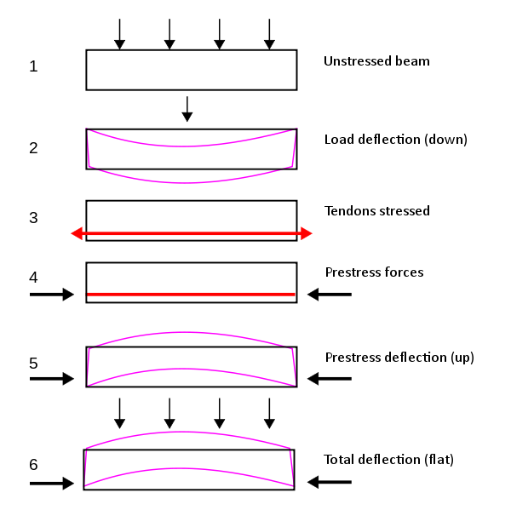

Fig 1.1: Forces in Prestressed Structure